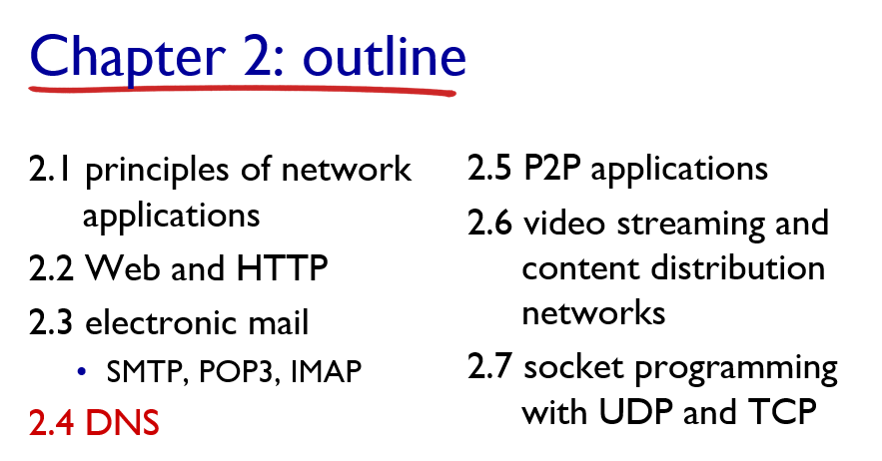2.1

Principles of Network Applications
Network applications enable communication between devices over a network (usually the Internet). Key principles include:
- Client-Server Architecture: The client requests services; the server provides them (e.g., web browsers and web servers).
- Peer-to-Peer (P2P): Devices (peers) act as both clients and servers (e.g., file sharing in BitTorrent).
- Processes and Sockets: A process runs a program; a socket connects it to the network.
- Application Layer Protocols: Define how messages are formatted and exchanged (e.g., HTTP, SMTP).

2.2 Web and HTTP (HyperText Transfer Protocol)
- HTTP is the protocol used by the web to transfer web pages.
- Stateless: Each HTTP request is independent.
- HTTP Methods:
  - GET: Request data.
  - POST: Send data to the server.
  - PUT, DELETE, etc. for REST APIs.
- HTTP Versions:
  - HTTP/1.1: Persistent connections.
  - HTTP/2: Multiplexing, faster performance.
- Web Components:
  - Browser (client), web server (e.g., Apache), content (HTML, CSS, JS).

2.3 Electronic Mail
Email systems involve user agents (UAs), mail servers, and protocols to send, receive, and store messages.
SMTP (Simple Mail Transfer Protocol)
- Used to send emails.
- Push protocol (client pushes email to the server).
- Works between email clients and servers, and between servers.
POP3 (Post Office Protocol v3)
- Used to receive emails.
- Downloads mail and deletes it from the server (by default).
- Simple, but not suitable for accessing email from multiple devices.
IMAP (Internet Message Access Protocol)
- Also used to receive emails.
- Keeps mail on the server.
- Supports multiple-device access, folders, and status flags (read/unread).

2.4 DNS (Domain Name System)
- Translates domain names (e.g., google.com) into IP addresses.
- Works like the Internet’s phonebook.
- Hierarchy: Root → Top-Level Domains (.com, .org) → Authoritative DNS.
- Steps in DNS resolution:
  - Local DNS cache checked.
  - Recursive DNS resolver queries root, TLD, then authoritative server.
  - IP is returned and used to contact the server.
- Types of DNS records:
  - A (IPv4 address), AAAA (IPv6 address), MX (mail exchange), CNAME (alias), etc.

2.5 P2P Applications (Peer-to-Peer)
- P2P (Peer-to-Peer) architecture allows devices (peers) to directly share resources (files, data, etc.) without a central server.
- Examples:
  - BitTorrent: Shares large files by dividing them into pieces.
  - Skype (early versions): Used P2P for voice and video communication.
- Advantages:
  - Scalable.
  - Reduces server costs.
- Challenges:
  - Security and privacy.
  - Managing data consistency.

2.6 Video Streaming and Content Distribution Networks (CDNs)
Video Streaming:
- Transmitting multimedia data (video/audio) over the Internet in real-time.
- Two types:
  - Live Streaming: Real-time broadcast (e.g., YouTube Live).
  - On-Demand Streaming: Pre-recorded (e.g., Netflix).
- Uses buffering to avoid delays.
CDNs (Content Distribution Networks):
- A network of distributed servers that deliver content (especially video) from the nearest location to the user.
- Improves:
  - Speed.
  - Reliability.
  - Load balancing.
- Examples: Cloudflare, Akamai, Amazon CloudFront.

2.7 Socket Programming with UDP and TCP
Socket: Endpoint for sending/receiving data over a network.
TCP (Transmission Control Protocol):
- Connection-oriented (3-way handshake).
- Reliable (data arrives in order, with error-checking).
UDP (User Datagram Protocol):
- Connectionless, faster but unreliable.
- No guarantee of order or delivery.

